Dataset Link: https://itv-contentbucket.s3.ap-south-1.amazonaws.com/Exams/Tableau/insurance.xlsx
Using insurance.xlsx file , perform the following.
- Change the datatype of Auto year column from number to date.
Ans:
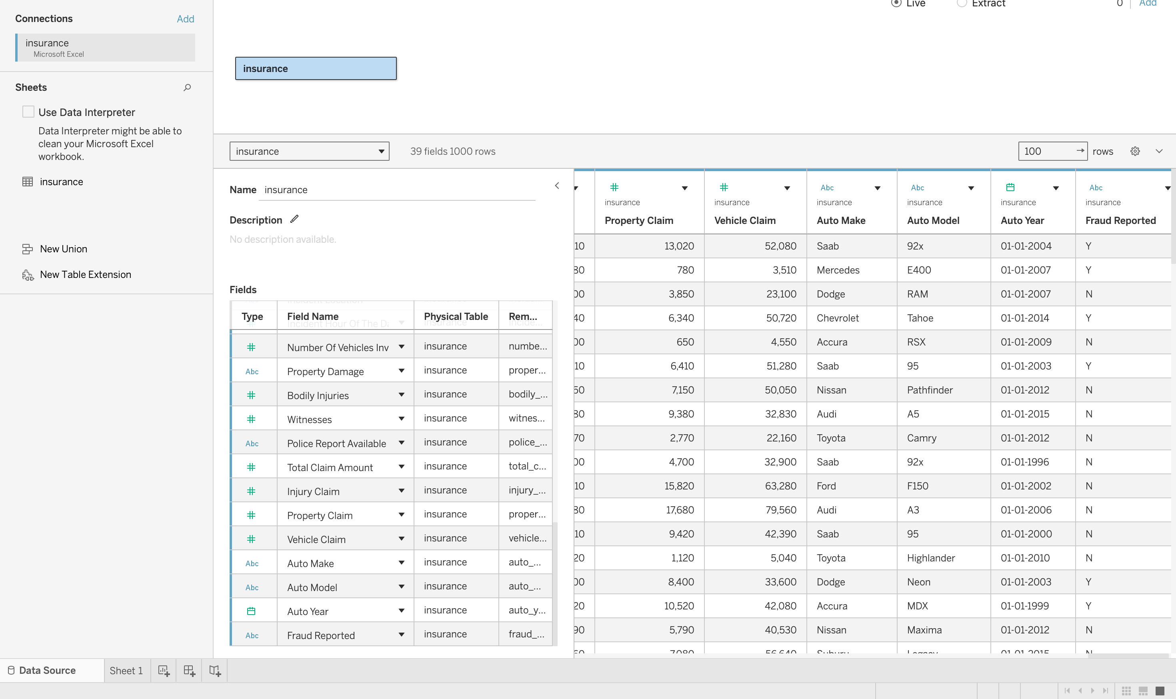

- Display day wise policy bind date vs capital gain using discrete and continuous axis.
Ans: 1. day wise policy bind date vs capital gain using discrete
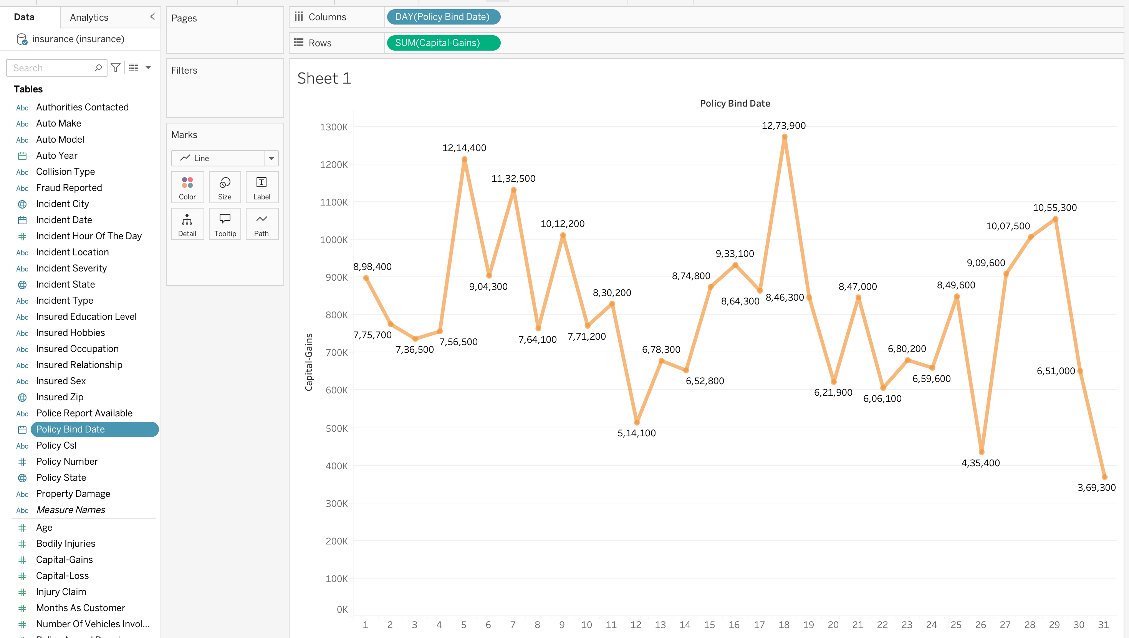
2. day wise policy bind date vs capital gain using continuous
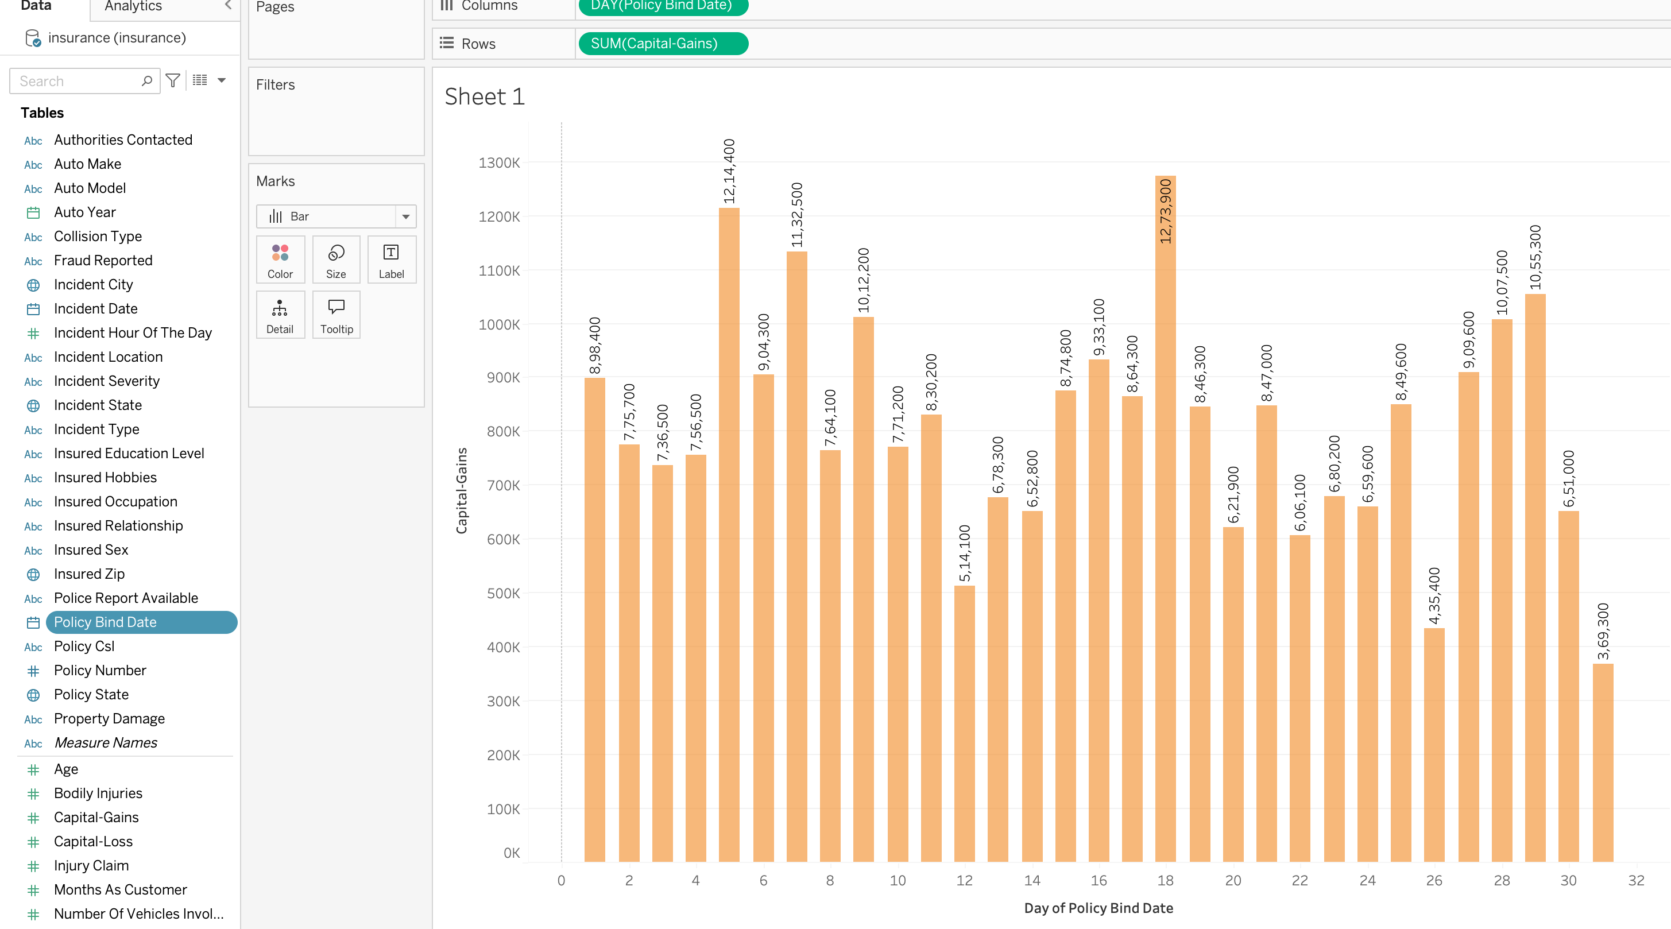
- What are the measure names and its values available in dataset.
Measure Names
Measure Names is a Tableau-generated field that contains the names of all measures in the dataset.
Examples from the Insurance dataset may include:
Months as Customer
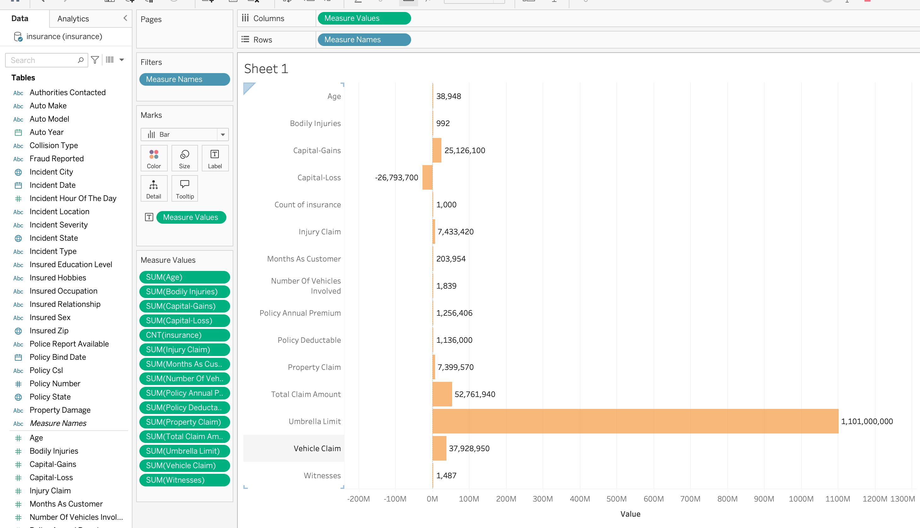
Age
Policy Deductable
Policy Annual Premiu
Umbrella Limit
Capital Gains
Capital Loss
Incident Hour of the Day
Bodily Injuries

Measure Values
Measure Values is another
Tableau-generated field that
contains the actual values of
the selected measures.
Example:
Measure Name | Measure Value
Capital Gains | 5000
Capital Loss | -2000
Total Claim Amount | 25000
Vehicle Claim | 12000

